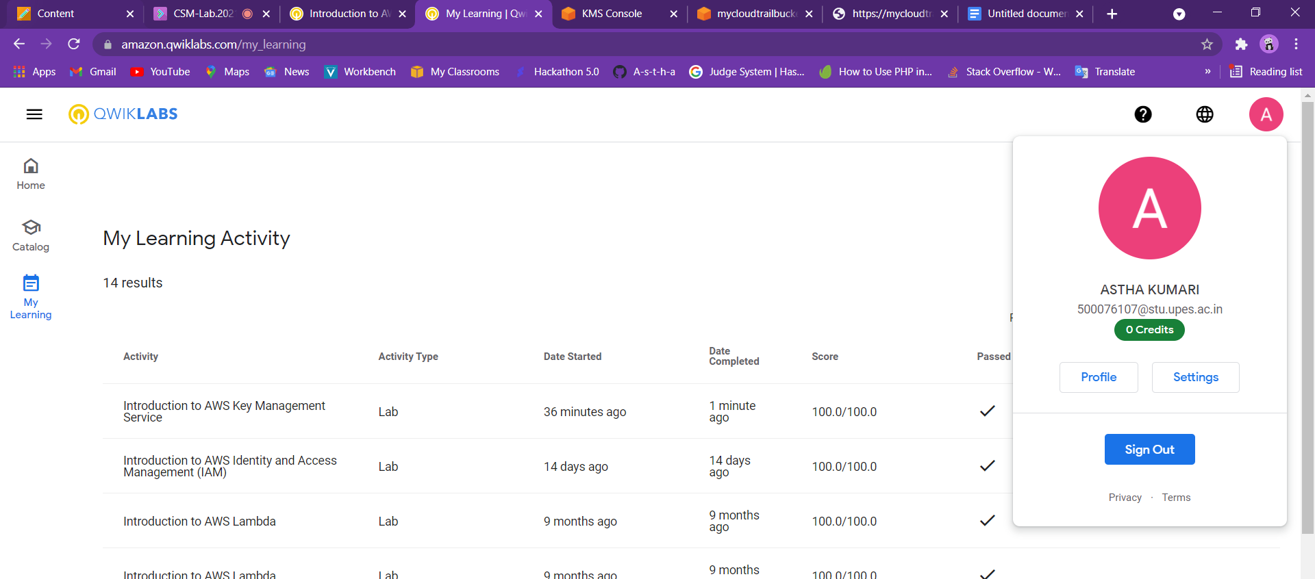

| [f5781011-b23e-4ec4-8106-4749d13dd192](https://us-west-2.console.aws.amazon.com/kms/home?region=us-west-2#/kms/keys/f5781011-b23e-4ec4-8106-4749d13dd192) |
| --- |

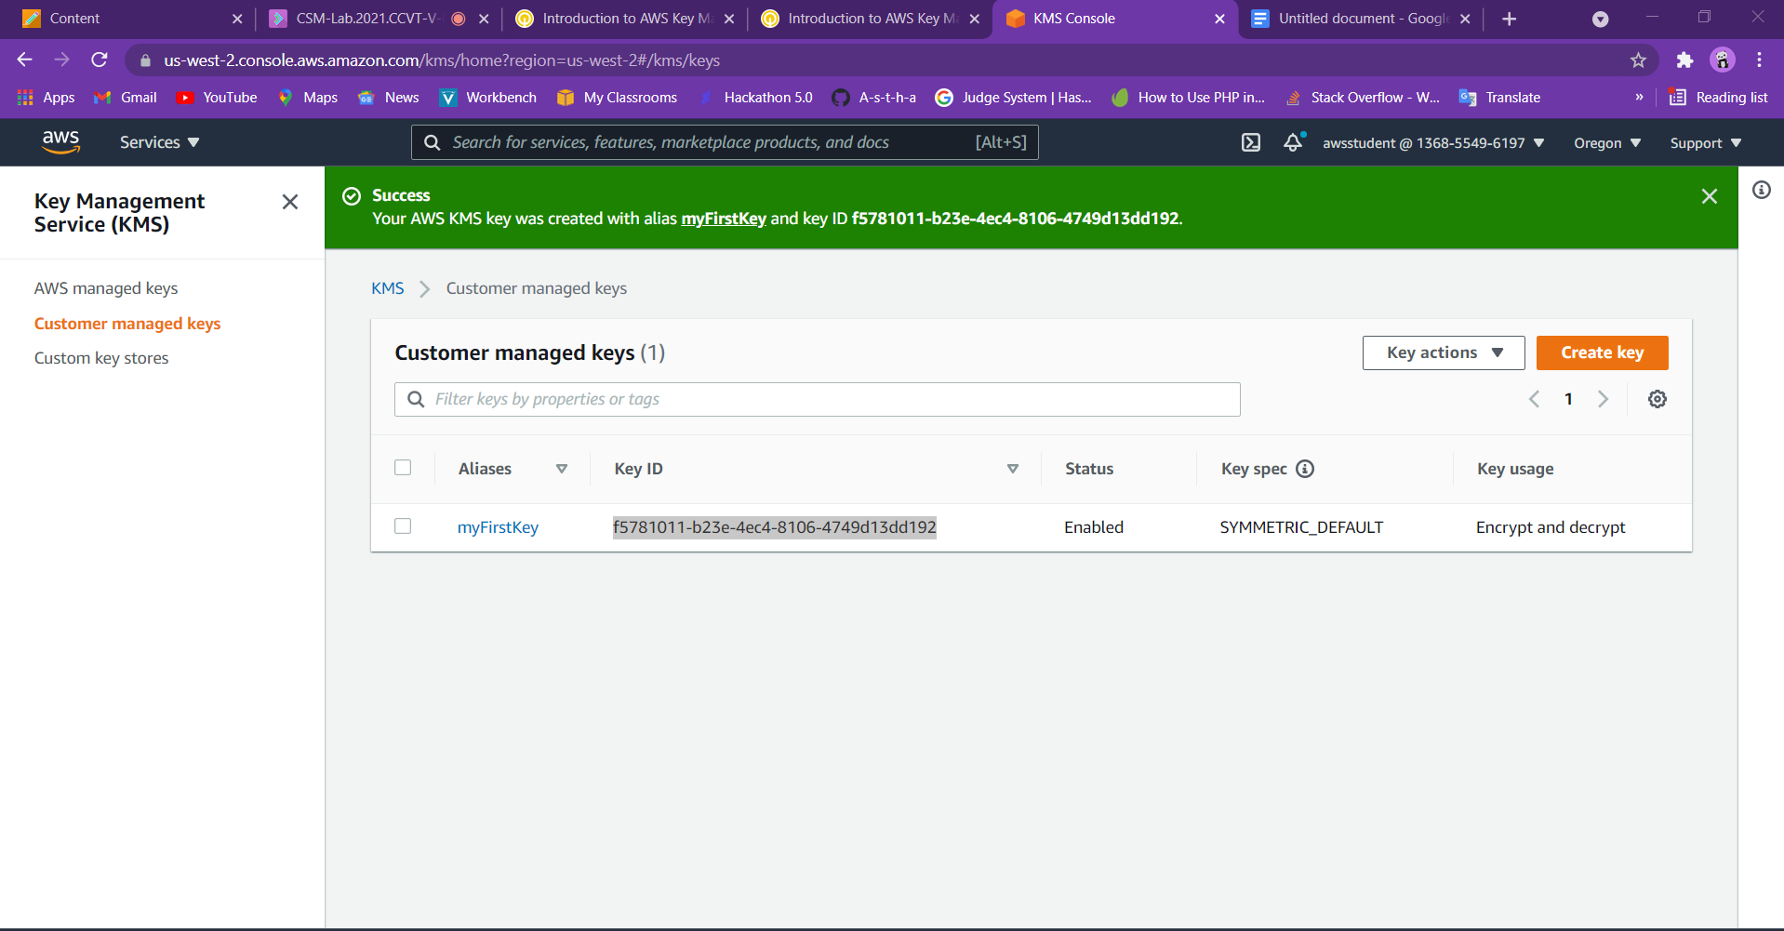

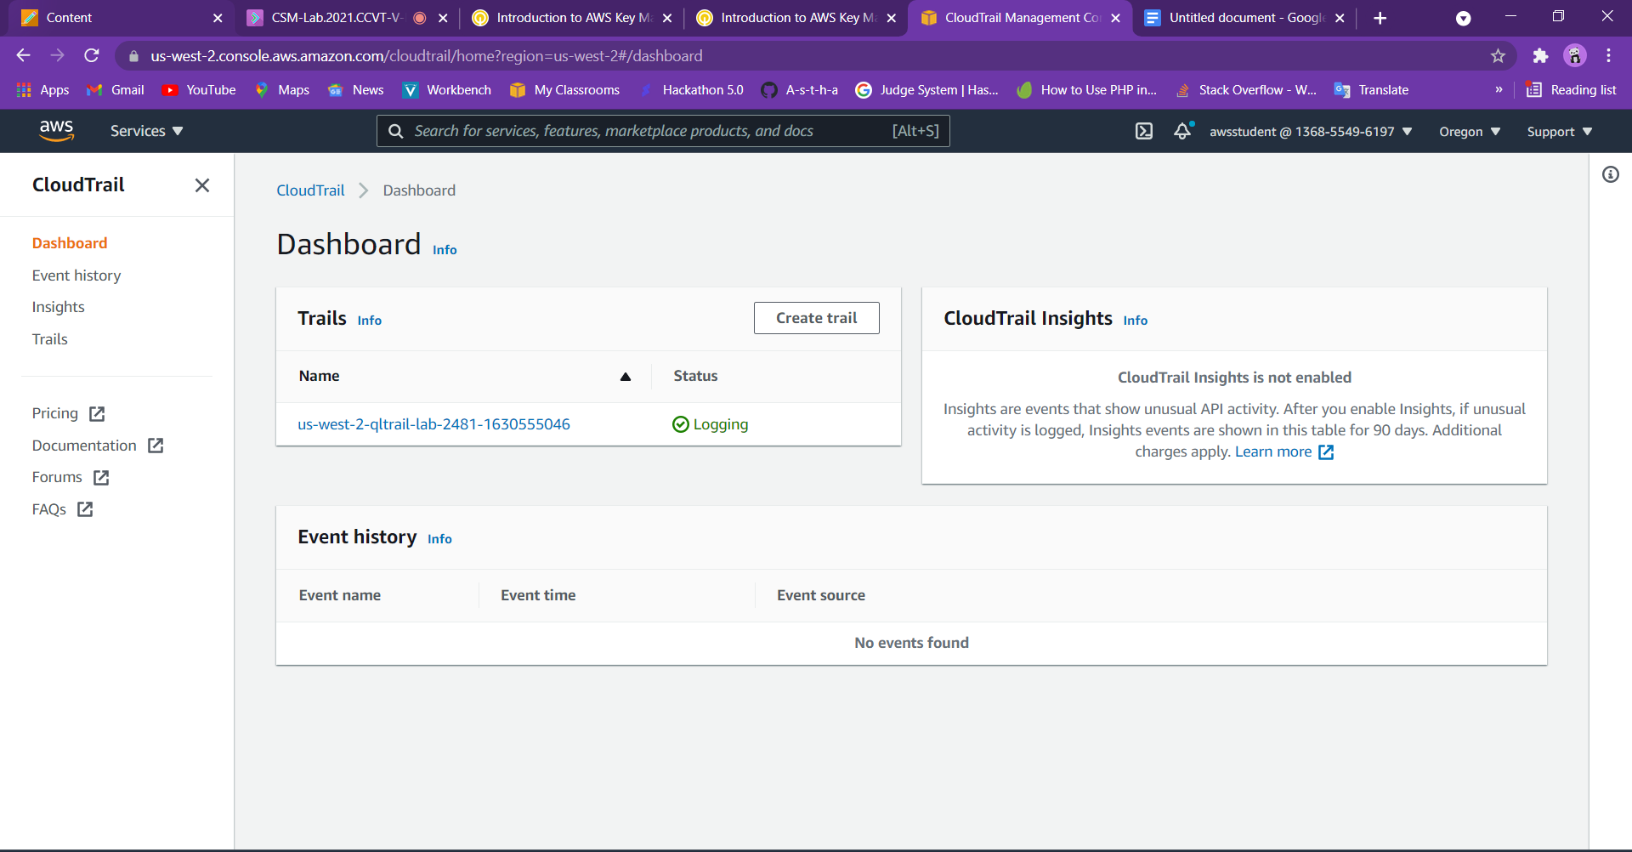

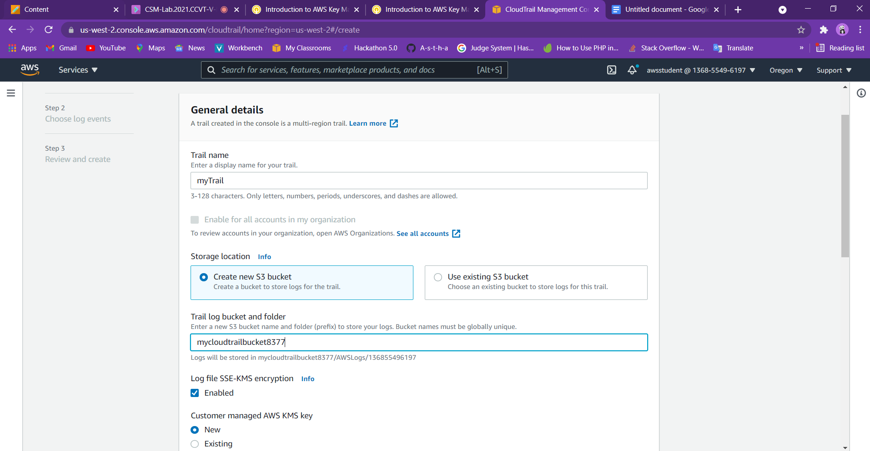

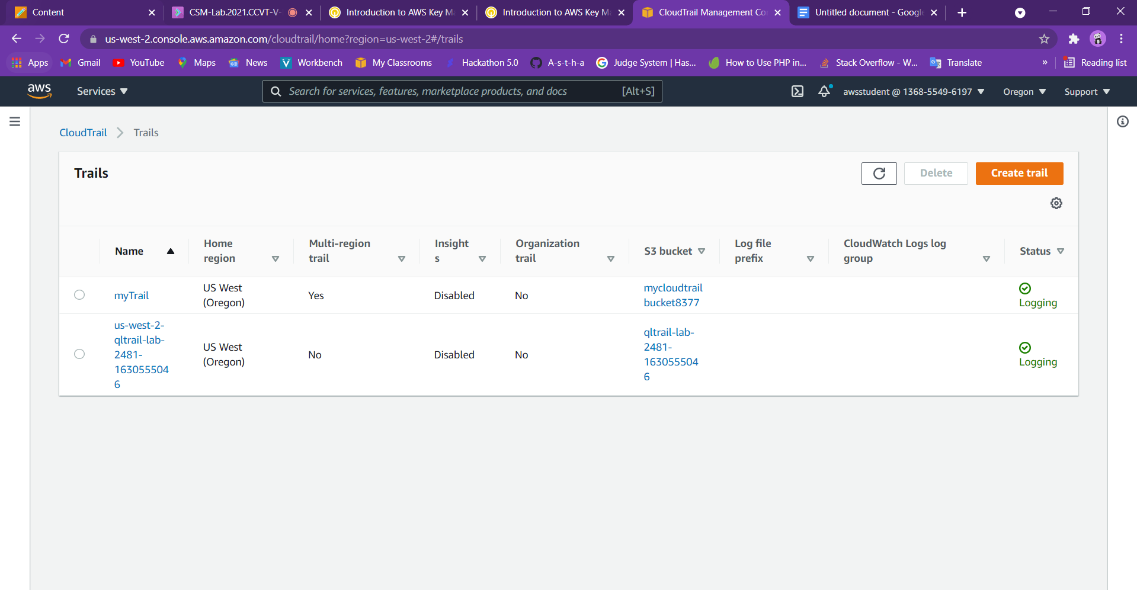

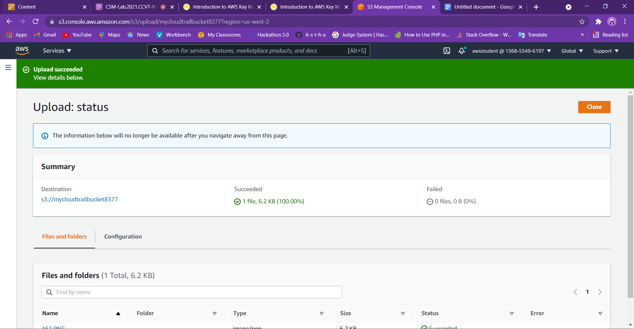

September 2, 2021, 09:40:25 (UTC+05:30)

s3://mycloudtrailbucket8377/AS1.PNG

